- What do you know about the graphs of each of the functions below if given:
Given Information | Give the equation of the horizontal asymptote  (if any) | Vertical asymptote  (if any) | Is the function continuous at x=c? If not what type of discontinuity is present?
$$\lim_{x→1}{g\left(x\right)=-∞}$$
$$\lim_{x→∞}{h\left(x\right)=0}$$
$$\lim_{x→1}{r\left(x\right)=4}$$ and
$$f\left(1\right)=6$$

- For the piecewise function f, what do the following limits appear to be?
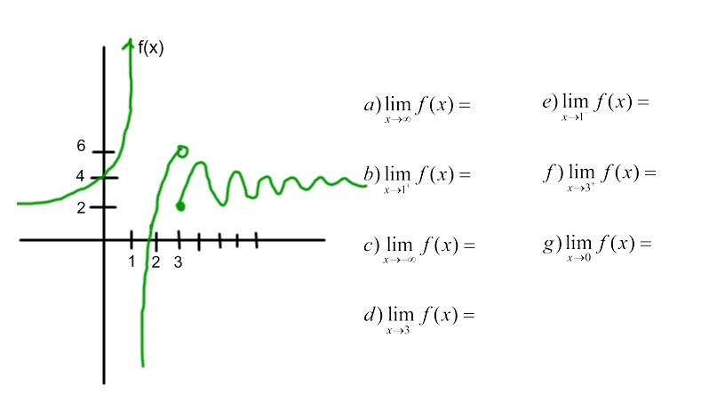
- Sketch the graph of a function that has a and f(2) = – 1

- Sketch the graph of a function that has the given features.
$$\lim_{x→2^{-}}{f\left(x\right)=∞}$$

$$\lim_{x→∞}{g\left(x\right)=∞}$$

- Find the following limits
$$\lim_{x→3^{}}{\frac{\sqrt{x+1}}{x-4}}$$

$$\lim_{x→∞}{\frac{3x^{4}-2}{2x^{2}+x-1}}$$

$$\lim_{x→3}{\frac{(3-x)^{2}}{(x-3)}}$$

- The graph of a function f whose domain is the closed interval [1,7] is shown below. Which of the following statements about f(x) is true? Which ones are false?
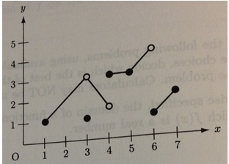
$$\lim_{x→3}{f(x)}=1$$
$$\lim_{x→4}{f\left(x\right)=3}$$
f(x) is continuous at x=3
f(x) is continuous at x=5
$$\lim_{x→6}{f\left(x\right)=6}$$

- If y=7 is the horizontal asymptote of a rational function f, then which of the following must be true? (Pick one)
$$\lim_{x→7}{f\left(x\right)=∞}$$
$$\lim_{x→-∞}{f\left(x\right)=-7}$$
$$\lim_{x→0}{f\left(x\right)=7}$$
$$\lim_{x→7}{f\left(x\right)=0}$$
$$\lim_{x→∞}{f\left(x\right)=7}$$

- Explain why the limit exists even though there is a hole in the graph.

