Directions: Print this paper or copy the entire tasks to a sheet of loose-leaf. Label the diagrams with appropriate tick marks and write a complete two column proof for both tasks. (Full credit on this handout counts for 100 homework points)
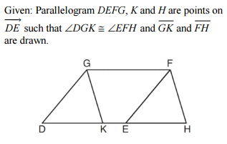
Prove: $∆GDK≅∆FEH$

Directions: The following proof involves the use of the CPCTC postulate. Remember to use this postulate you must first prove the triangles are congruent.
