Use the product rule to differentiate the following, show all work! (Check your answers at wolframalpha.com)
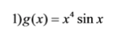
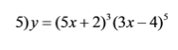
2

$3)f\left(x\right)=\left(-3+x^{-3}\right)(-4x^{3}+3)$

Use the quotient rule to differentiate the following, show all work! (Check your answers at wolframalpha.com)
$$4)f\left(x\right)=\frac{sinx-3x}{x}$$

$$5)f\left(x\right)=\frac{3(1-sinx)}{2cosx}$$

$$6)f\left(x\right)=\frac{3x-1}{\sqrt{x}}$$

