Directions: Do your best to answer every question. Partial credit will be earned for correct work that does not result in a correct answer. Correct answers without supporting work will not receive full credit.
- Multiply the following:
- ${(x}^{2})\left(5x^{3}\right)=$
- $\left(3x^{3}\right)\left(6x^{4}\right)=$

- Write the following in simplest form
$$\frac{{5x}^{4}}{10x}$$

- Factor the following:
- $9x^{4}-27x^{6}$
- $25x-125$
- $x^{2}-3x-18$
- $x^{2}-64$

#’s 4 – 10 are Multiple choice but you must still show work

- What is 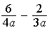 expressed in simplest form?
1) 2) 3) 4) 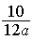
- The expression 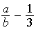 is equivalent to
1) 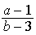 2) 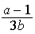 3) 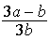 4) 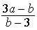
- What is 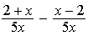 expressed in simplest form?
1) 0 2) 3) 4) 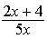
- What is 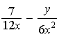 expressed in simplest form?
1) 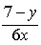 2) 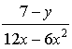 3) 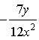 4) 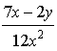

- Which expression represents 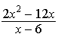 in simplest form?
1) 0 2) 3) 4)

- Which expression represents 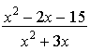 in simplest form?
1) 2) 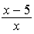 3) 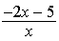 4) 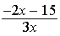

- What is the product of $\frac{x^{2}-1}{x+1} and \frac{x+3}{3x-3}$?

1) $x$ 2) $\frac{x}{3}$ 3) $x+3$ 4) $\frac{x+3}{3}$

- Express in simplest form: 