Directions: Complete this packet by Monday May 2nd 2016 in addition to this you must by a compass (To make circles). This is due Monday May 2nd 2016. If necessary do the work on a separate sheet of loose-leaf.
1) What is the midpoint of CD if it’s endpoints are C(-8, -7) and D(2, 3)?
2) What is the distance between the points (-5, 4) and (5, 9)? Express you answer in simplest radical form.
3) If two sides of a triangle are 8 and 4, is it possible for the third side to be 18? Explain.
4) In the diagram below, transversal intersects and at V and W, respectively.
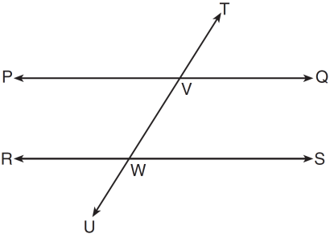
If and , for which value of x is 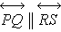?
5) If the vertices of are , , and , can we classify as scalene? Explain.
6) In , , , and . List the angles of in order from least to greatest.
7) In the diagram below, and at R.
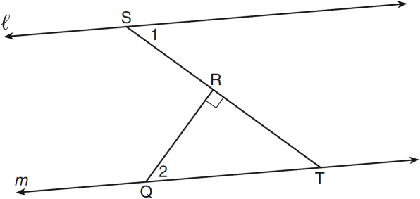
If , find .
8) In the diagram below of with side extended through D, and . Find the measure of Angle B. Which side of is the longest side? Justify your answer.
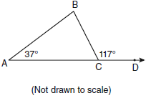
9) The angles of triangle ABC are in the ratio of . What is the measure of the smallest angle?

10) Can the following set of lengths represent the sides of a right triangle? Why or why not?
{16, 63, 65}
11)
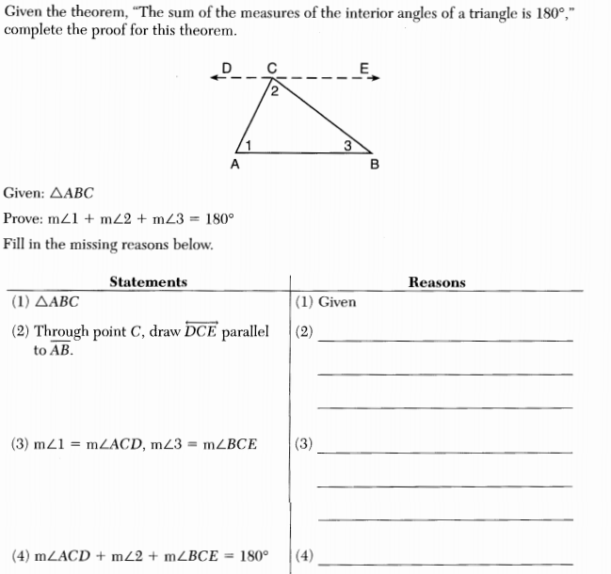
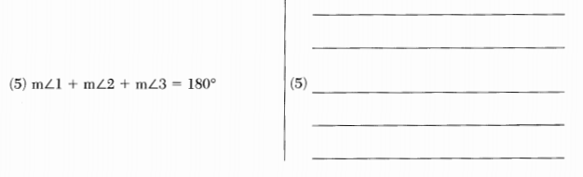
12) What is an equation that represents the line that is perpendicular to and passes through the point ?

13) In the diagram below of , H is a point on , , , and . Determine whether is an isosceles triangle and justify your answer.
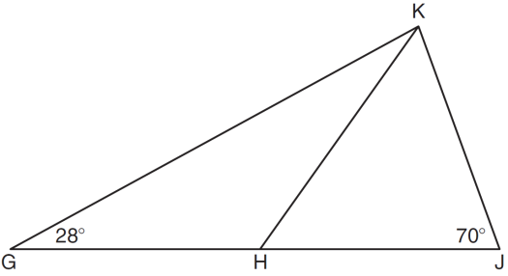
14)Jim is experimenting with a new drawing program on his computer. He created quadrilateral TEAM with coordinates , , , and . Jim believes that he has created a rhombus but not a square. Prove that Jim is correct. [The use of the grid is optional.]
15) 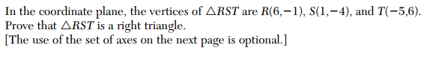 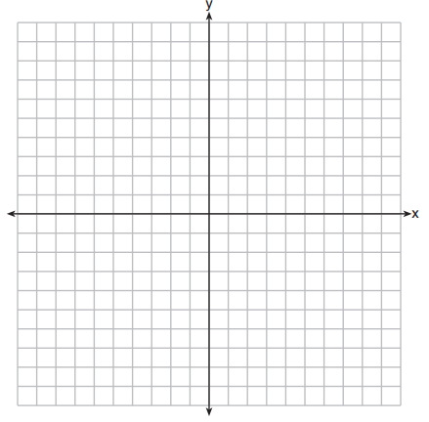

16)
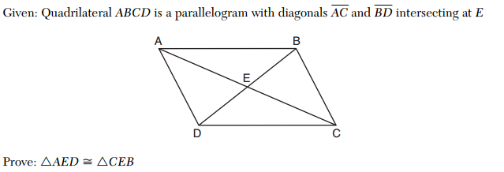

17)

18)
